RIPHAH INTERNATIONAL UNIVERISTY ISLAMABAD


LAB # 12
SUBMITTED TO : Mam hasnat
SUBMITTED BY: Fatima nazir 45317

TASK 1
#include <iostream>
using namespace std;

int tempCount = 1;
int labelCount = 1;

string newTemp() {
return "t" + to_string(tempCount++);
}

string newLabel() {
return "L" + to_string(labelCount++);
}

int main() {
// while (a < 10) { a = a + 1; }

string startLabel = newLabel();
string endLabel = newLabel();

cout << startLabel << ":" << endl;

string t1 = newTemp();
cout << t1 << " = a < 10" << endl;

cout << "if " << t1 << " == 0 goto " << endLabel << endl;

string t2 = newTemp();
cout << t2 << " = a + 1" << endl;
cout << "a = " << t2 << endl;

cout << "goto " << startLabel << endl;

cout << endLabel << ":" << endl;

return 0;
}
Output
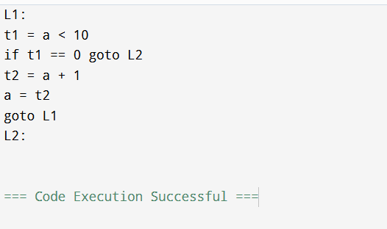

TASK 2
#include <iostream>
using namespace std;

int tempCount = 1;
int labelCount = 1;

string newTemp() {
return "t" + to_string(tempCount++);
}

string newLabel() {
return "L" + to_string(labelCount++);
}

int main() {
// (x > 0) && (y < 10)

string Lfalse = newLabel();
string Lend = newLabel();

string t1 = newTemp();
cout << t1 << " = x > 0" << endl;
cout << "if " << t1 << " == 0 goto " << Lfalse << endl;

string t2 = newTemp();
cout << t2 << " = y < 10" << endl;
cout << "if " << t2 << " == 0 goto " << Lfalse << endl;

string t3 = newTemp();
cout << t3 << " = 1" << endl;
cout << "goto " << Lend << endl;

cout << Lfalse << ":" << endl;
cout << t3 << " = 0" << endl;

cout << Lend << ":" << endl;

return 0;
}
